

INTERNAL

UFT Scripts Execution via Jenkins

v0.1

Table of ContentS

method 1 – Remote execution 3

1. Add Remote Server as Jenkins Node 3

2. Setup agent in Remote Server 4

3. Prepare VBScript to launch the Jenkins Job 8

4. Create Jenkins Job 8

5. Config startUFT.vbs file 10

6. Trigger the Jenkins Build 11

method 2 – Jenkins plugin 11

This document aims to describe how to setup UFT Execution Job on Jenkins server

# method 1 – Remote execution

This method is to use Jenkins to trigger the UFT Scripts Execution on dedicated Remote Server

## 1. Add Remote Server as Jenkins Node

In order to trigger the UFT Scripts Execution, we need first connect remote server as Jenkins Node

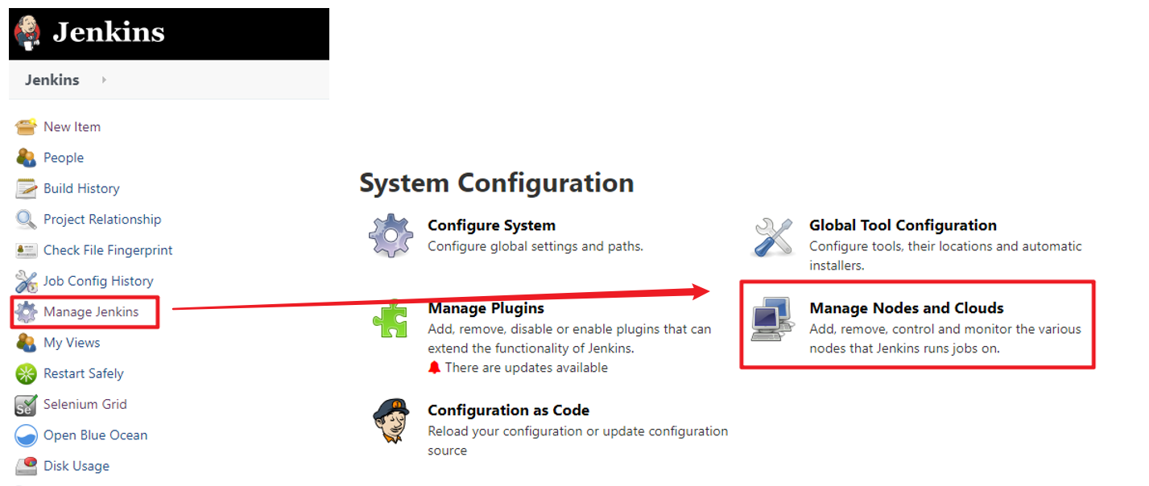

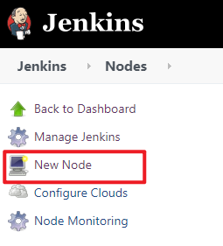 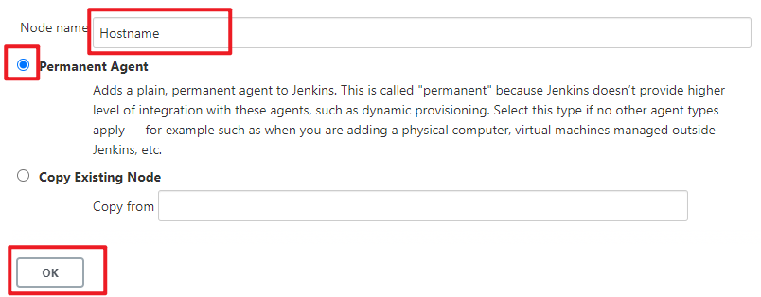

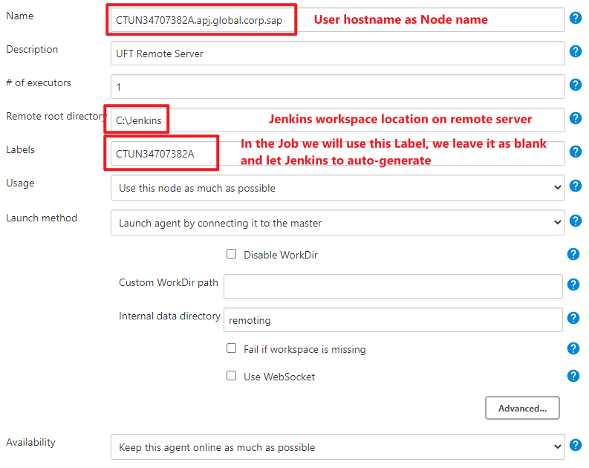

## 2. Setup agent in Remote Server

2.1 Login to Remote Server with Administrator Account

2.2 Open Jenkins, go to configured Nodes page, download the agent file: **slave-agent.jnlp**

*\*\*\* make sure you have JRE installed on Remote Server*

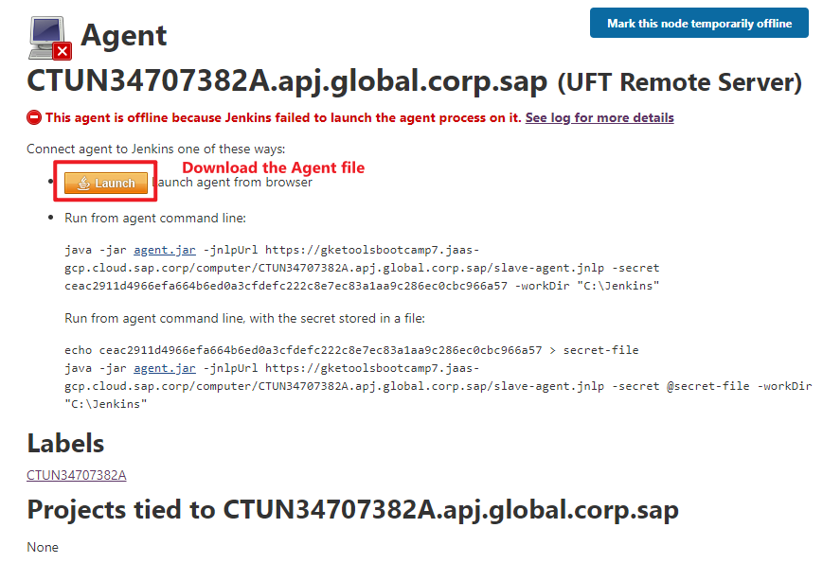

2.3 Open CMD as Administrator and launch the **slave-agent.jnlp** agent

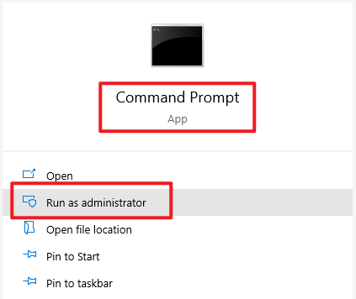

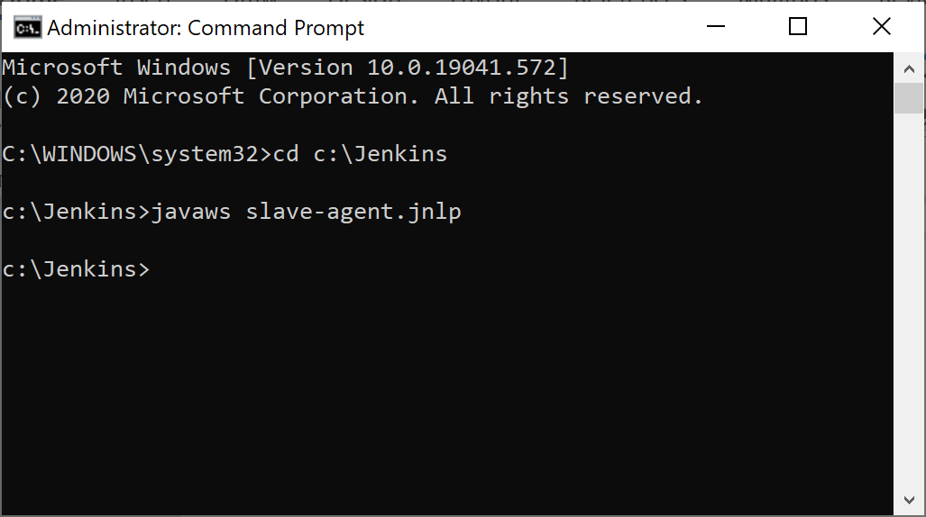

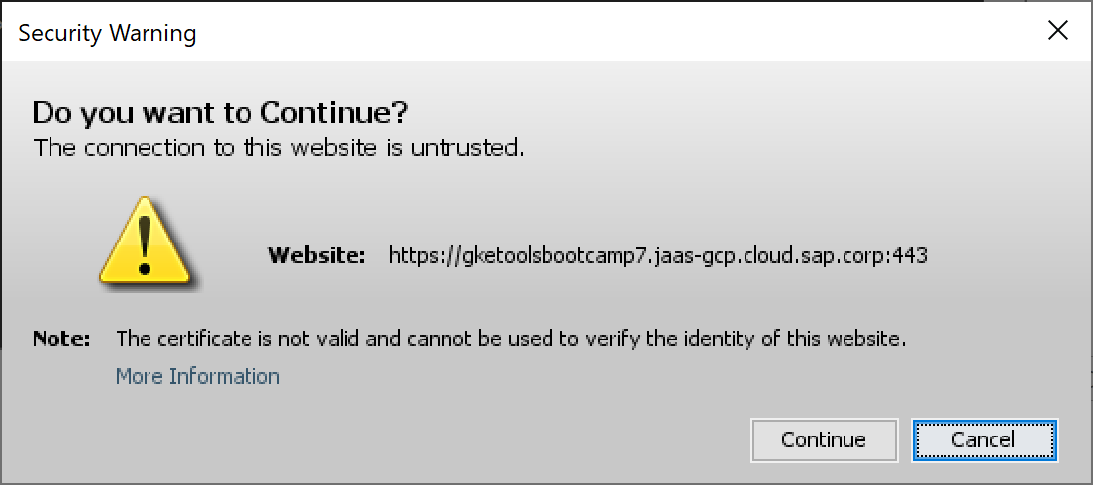

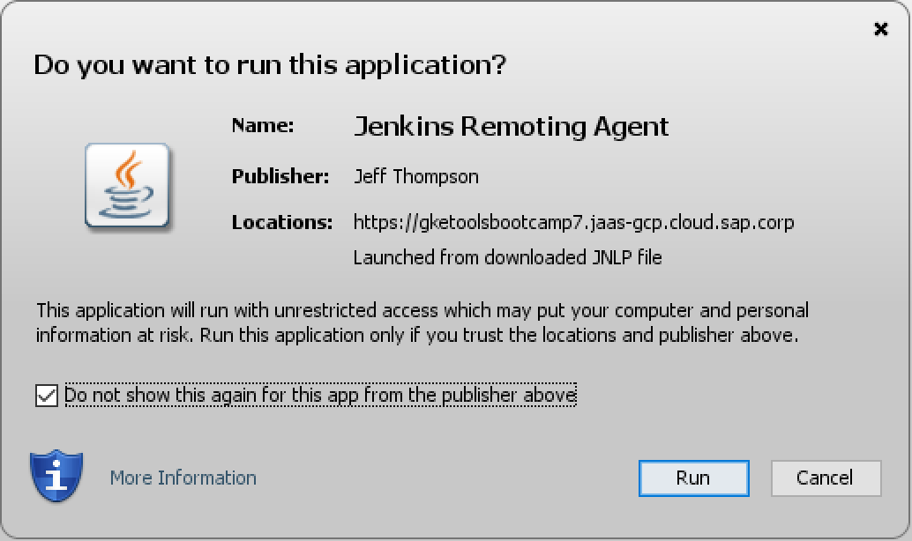

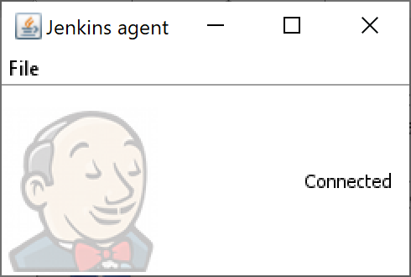

After executed the Jenkins Agent, refresh the Node page, it should be displayed as connected.

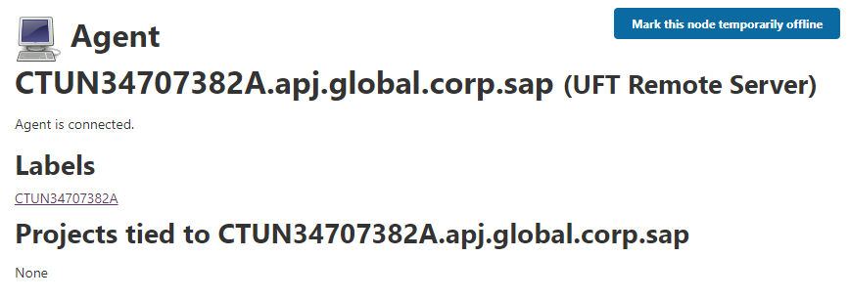

2.4 Install Jenkins Agent as Service

We can install Jenkins agent as Service then it will not require to execute the agent every time manually.

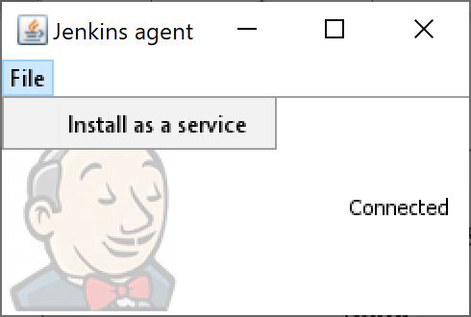

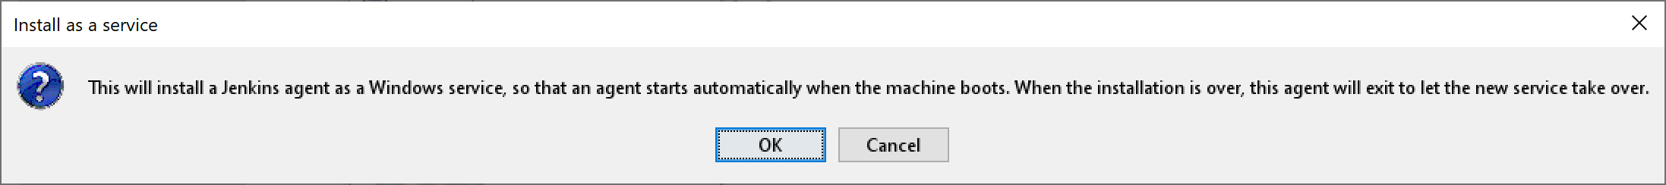

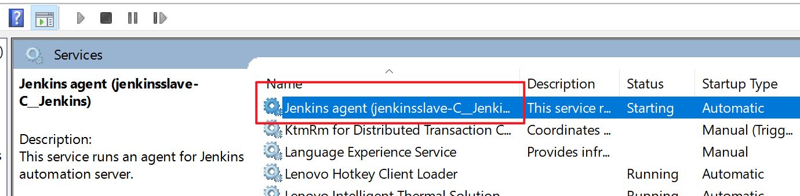

*\*\*\* It cannot start successfully after the install, we need to fix this issue by editing the* ***Jenkins-slave.xml*** *file, add* ***-noCertificateCheck*** *before -secret. Then start the Service again*

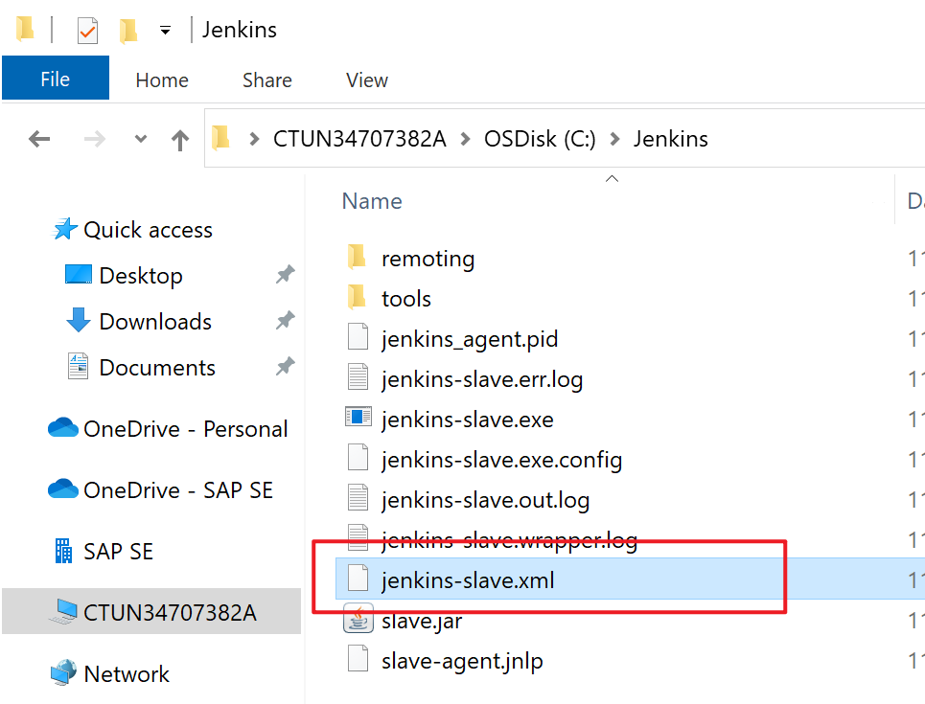

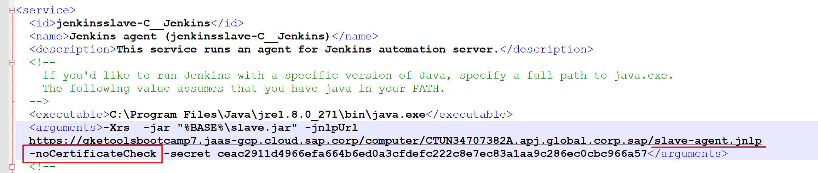

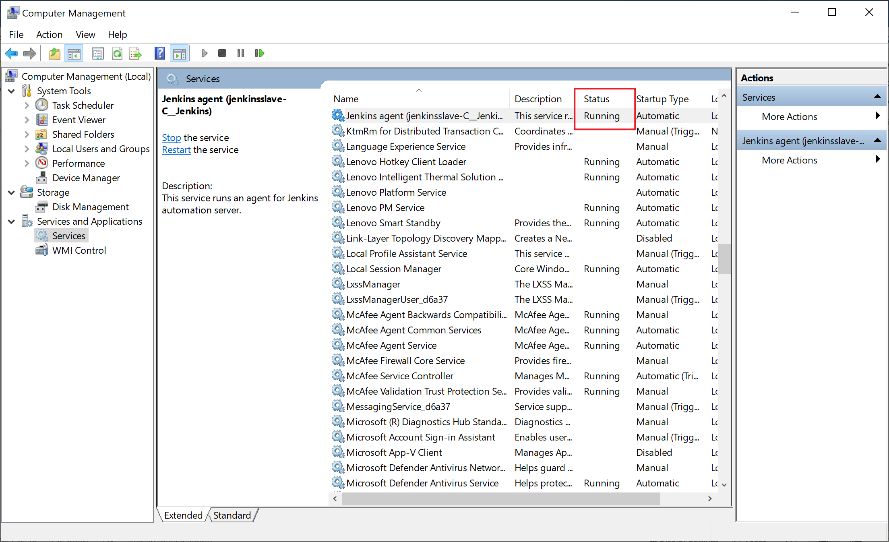

## 3. Prepare VBScript to launch the Jenkins Job

Upload the attached startUFT.vbs to Remote Server Jenkins folder (or any other folder is ok)



We need to modify the script path later after Job created.

## 4. Create Jenkins Job

4.1 Create new Job

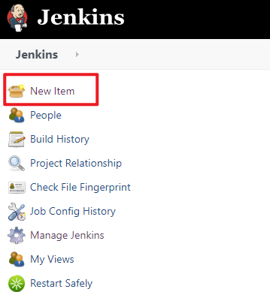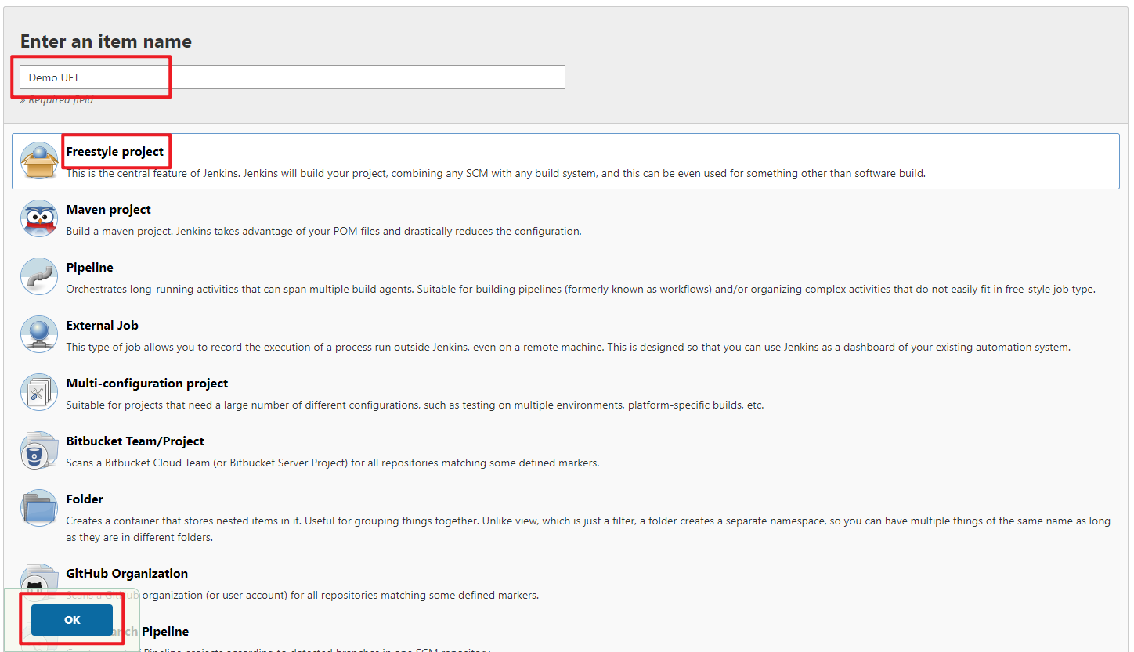

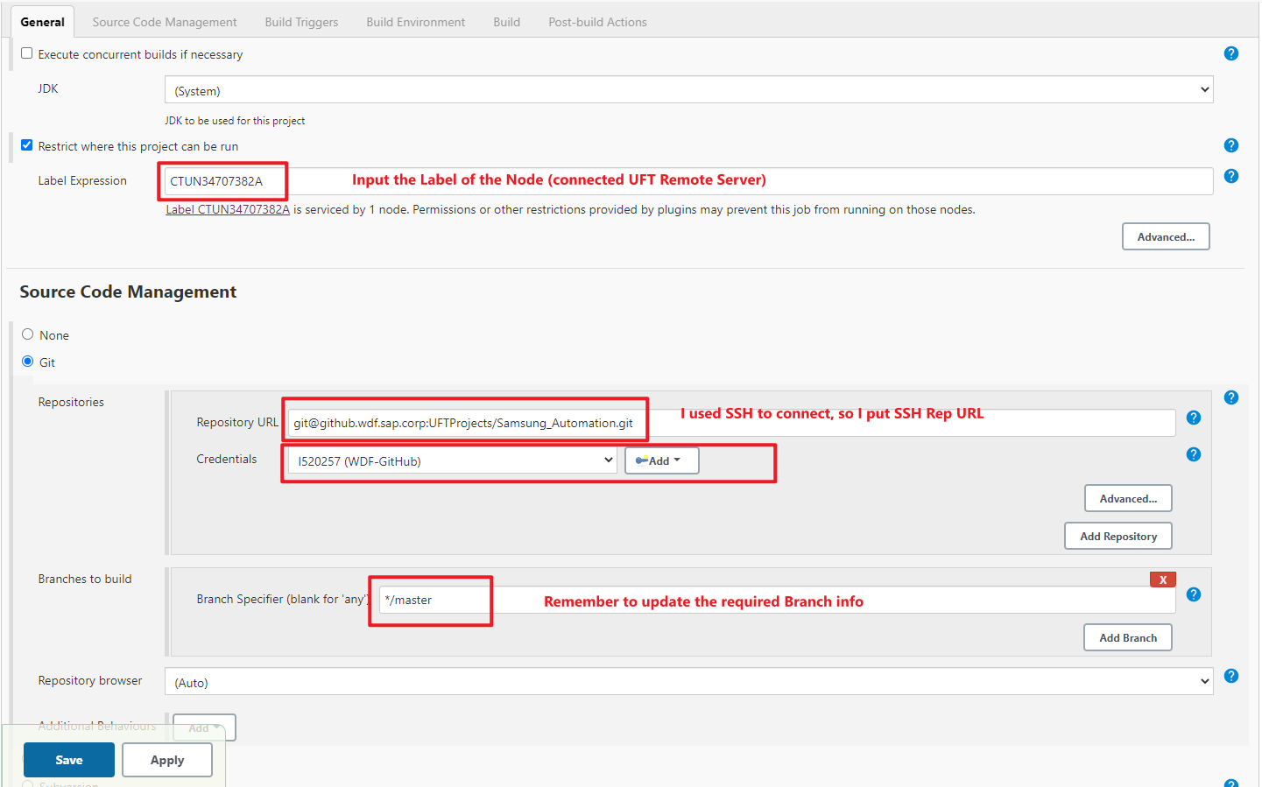

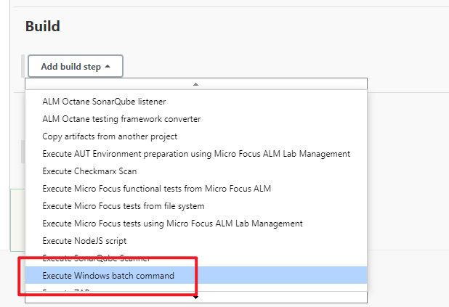

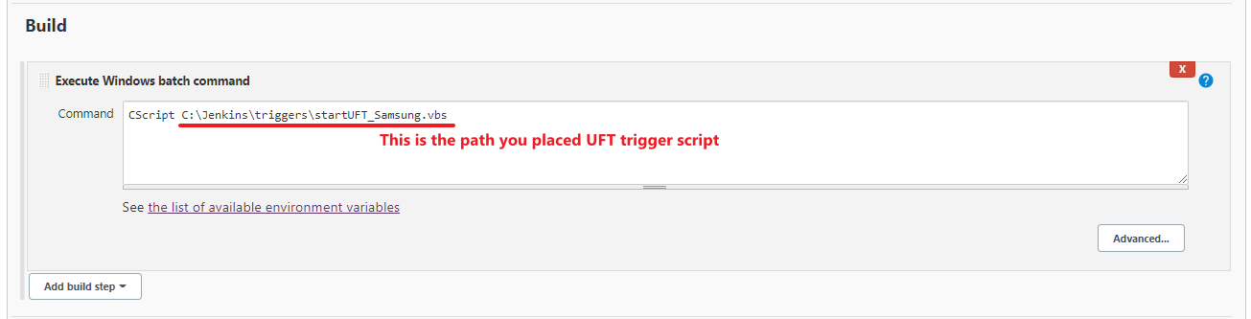

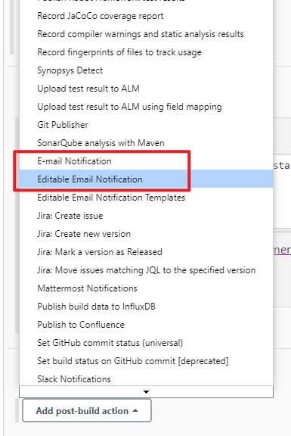

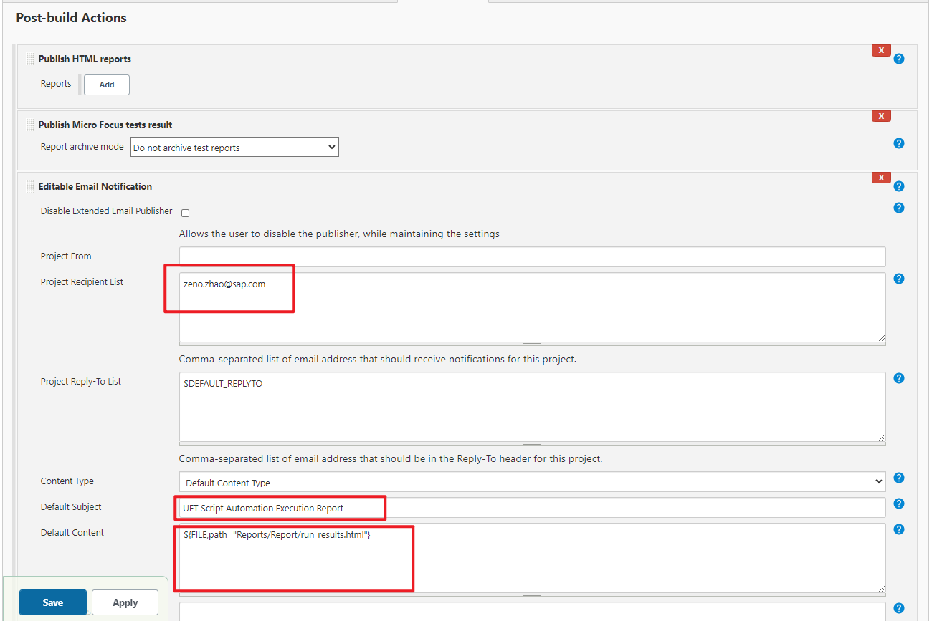

## 5. Config startUFT.vbs file

Update the startUFT.vbs file

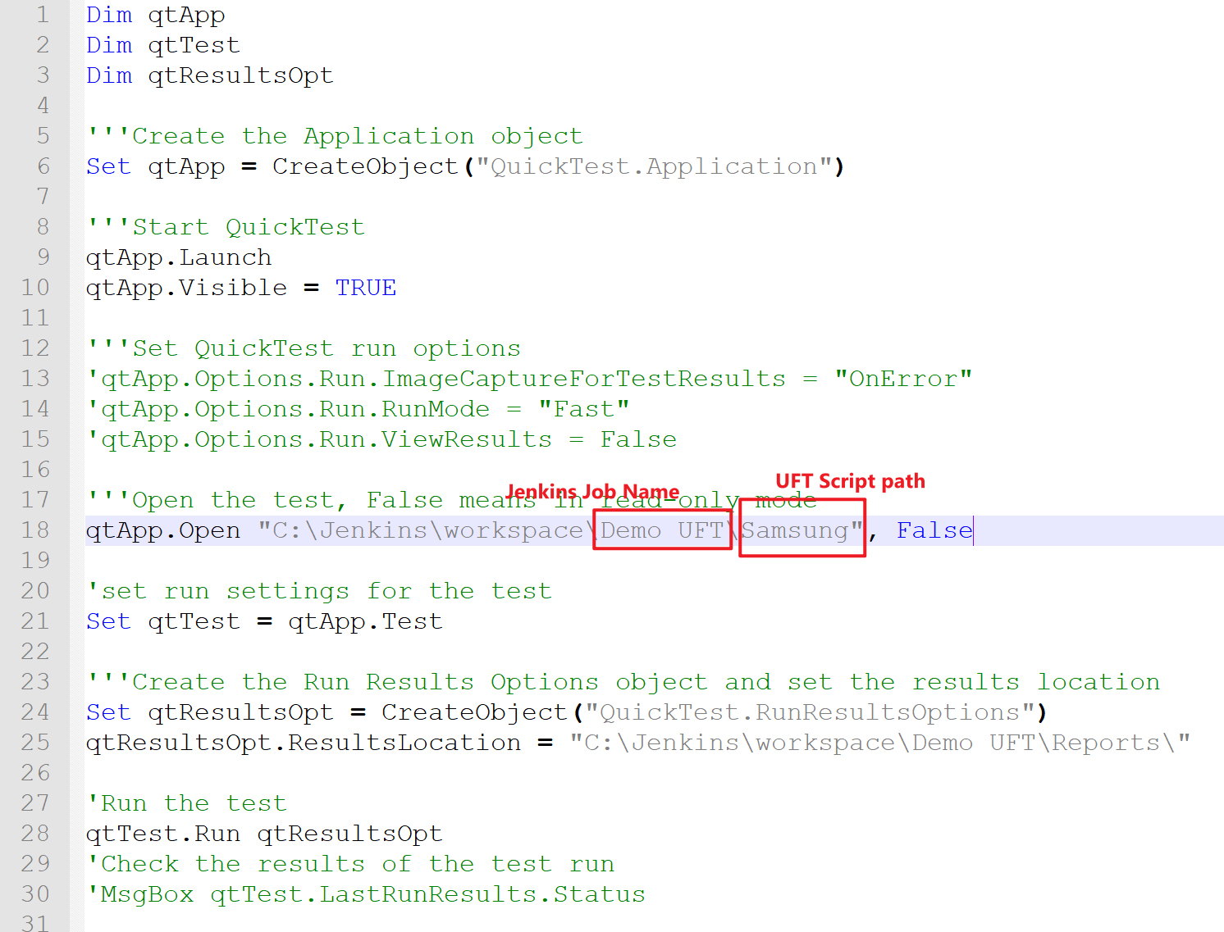

## 6. Trigger the Jenkins Build

# method 2 – Jenkins plugin

Micro Focus provides Jenkins Plugin to make it possible to run UFT scripts as part of Jenkins continuous integration process.

For this method, the UFT scripts are located in Jenkins server itself, UFT should be installed on Jenkins server itself

More details please refer to Micro Focus help portal

https://admhelp.microfocus.com/uft/en/15.0-15.0.1/UFT_Help/Content/User_Guide/Jenkins.htm